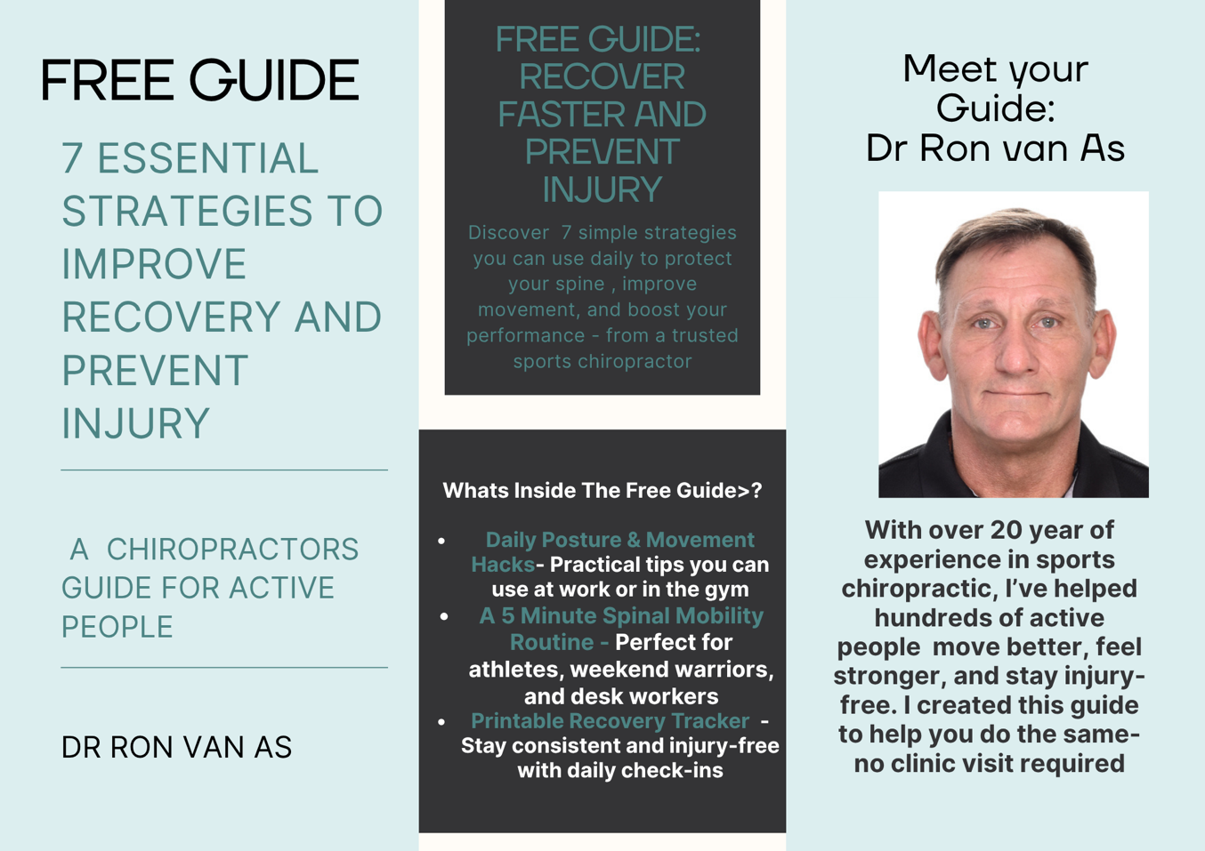

**🧠 7 Essential Strategies to Improve Recovery and Prevent Injury**

**A Chiropractor’s Guide for Active People**

By Dr.Ron van As — Sports Chiropractor & Wellness Expert, Lusaka

**💪 1. Move Smart, Not Just Hard: Posture in Motion**

Whether you’re training at the gym or working at your desk, posture matters. Repeated stress from poor alignment can lead to joint wear, muscular imbalance, and long-term injury.

✅ Quick Fixes:

Standing: Feet shoulder-width apart, core gently engaged, shoulders relaxed.

Sitting: Use a lumbar support, keep knees at 90°, and avoid leaning forward for extended periods.

Lifting: Hinge at the hips, not your back. Keep the load close to your body.

**🧘 2. Your Daily 5-Minute Mobility Reset**

Incorporate these movements daily—especially if you’re active or sit a lot.

PILOGA-Inspired Routine:

**Cat-Cow (30 secs)** – Mobilizes spine

**Child’s Pose (30 secs)** – Releases low back tension

**Spinal Twist (1 min each side)** – Improves thoracic rotation

**Glute Bridge (10 reps)** – Activates posterior chain

**World’s Greatest Stretch (1 min)** – Full-body opening

> Do these once a day to stay fluid, aligned, and pain-free.

**💧 3. Recovery Starts with Hydration & Inflammation Control**

Muscles and discs in your spine need proper hydration to function and recover.

Tips:

Drink at least 30ml per kg of body weight daily.

Add magnesium and potassium-rich foods (spinach, banana, coconut water).

Use cold packs post-exercise for inflammation; heat for chronic tightness.

**⚠️ 4. Know the Red Flags**

Listen to your body before small issues become major setbacks.

Don’t Ignore:

* Numbness, tingling, or shooting pain
* Persistent stiffness or tension in one area
* One-sided headaches or migraines after workouts
* Clicking or grinding joints with reduced range of motion

If these persist, see a licensed chiropractor or physiotherapist.

**😴 5. Optimize Sleep for Spinal Recovery**

Your spine decompresses and heals while you sleep. Poor sleep posture can undo all your recovery work.

Best Practices:

* Side sleeper: Place a pillow between your knees
* Back sleeper: Use a pillow under knees to flatten lower back
* Avoid sleeping on your stomach – It twists the neck and compresses the low back

**🧑‍⚕️ 6. When Should You See a Chiropractor?**

Athletes often wait until they're in pain—but early intervention boosts performance and prevents breakdown.

Ideal Times to Visit:

* Before a competitive event or race
* When training volume increases
* After any impact or fall
* If you feel “off” or unbalanced in your movements

> Chiropractic care can help you recover faster, move better, and prevent injury—naturally.

**📊 7. Bonus: Daily Mobility & Posture Tracker**

Use this tracker to build consistent habits over the next 7 days:

|  |
| --- |
| Day Mobility Done (Y/N) Good Posture (Y/N) Water Intake Met (Y/N) |
|  |
| 1 |
| 2 |
| 3 |
| 4 |
| 5 |
| 6 |
| 7 |

Print it or save to your phone. Small changes lead to lasting results!

**🎁 Want More?**

If you found this helpful, you’ll love what’s coming next.

👉 Book a consultation with Dr.Ron van As – Zambian Chiropractic

👉 Join the waitlist for the upcoming online course: Unlock Peak Performance: Spinal Health for Athletes

👉 Follow us for daily tips on Instagram @YourHandle

🙌 Yours in Alignment,

Dr.Ron van As

Sports Chiropractor | Creator of PILOGA | Recovery & Wellness Coach

📍 Lusaka, Zambia

🌐